EXPLORE WITH AI : CUSTOM ITINERARIES FOR YOUR NEXT JOURNEY

INTRODUCTION

Project Overview
Project Title: Explore With AI: Custom Itineraries For Your Next Journey
Team ID: LTVIP2026TMIDS63324

Team Members:
    - M Ritheesh
    - Trisha T
    - Kamesh Nataraj
    - M Bharath
This project is a web-based intelligent travel planning system that generates personalized travel itineraries using Generative AI. The system accepts user preferences such as destination, duration, budget, and interests, and produces customized day-wise travel plans. By leveraging AI services, the platform simplifies trip planning and enhances the user experience.

Purpose
The purpose of this project is to:
    - Help users plan trips easily without manual research
    - Provide customized travel itineraries based on preferences
    - Save time by automating travel plan generation

IDEATION PHASE

Problem Statement
Planning travel itineraries requires extensive research across multiple websites, which is time-consuming and confusing. Travelers often struggle to organize activities, estimate time usage, and ensure efficient scheduling. Therefore, an intelligent automated system is needed to generate customized travel plans instantly.

Empathy Map Canvas
Users Feel Think Do Pain Points

Travelers
Excited but confused
“How to plan my trip?”
Search online
Too much information

Tourists want convenience
“I need quick planning”
Compare options Time consuming

Students
Budget conscious “Affordable plan”
Look for deals Planning difficulty

Brainstorming
Different solutions were considered:
    - Manual itinerary templates
    - Static travel guides
    - AI-based fraud detection
Chosen Solution:
Generative AI-based system because it provides dynamic, personalized, and scalable travel planning..

REQUIREMENT ANALYSIS

Customer Journey Map
- User enters travel preferences
- System processes input
- Generative AI creates itinerary
- System displays travel plan

Solution Requirement Functional Requirements
    - Accept travel inputs (destination, duration, preferences)
    - Generate itinerary using AI
    - Display structured travel plan
    - Allow multiple queries

Non-Functional Requirements
    - Fast response
    - User-friendly interface
    - Reliable AI output
    - Secure data handling

Data Flow Diagram
- User → Web Interface
- Interface → Backend
- Backend → Generative AI API
- AI → Generated Itinerary
- Result → User Interface

  - Technology Stack Layer Technology Frontend HTML, CSS Backend Python
AI Gen AI
Database JSON
Tools VS Code, GitHub

PROJECT DESIGN

Problem–Solution Fit
Travel planning is complex and time-consuming. Our solution provides instant AI-generated itineraries, improving convenience and user satisfaction.

Proposed Solution
A web application integrated with Generative AI that produces customized travel itineraries based on user input.

Solution Architecture
User → Web Page → Backend Server → Generative AI → Generated Plan → User

PROJECT PLANNING & SCHEDULING
Phase Duration RequirementAnalysis 1 week AI Integration 2 weeks UI Development 1 week Backend Integration 1 week Testing 1 week

FUNCTIONAL AND PERFORMANCE TESTING

Performance Testing
    - Generates itinerary within seconds

    - Tested with multiple travel inputs
    - Provides Structured outputs consistently

RESULTS
The system successfully generates as:
- Personalized itineraries Safe
- Day-wise travel plans
- Customized travel suggestions
The web interface clearly displays the generated itinerary.

Output Screenshots
Screenshots include:
    - Home page
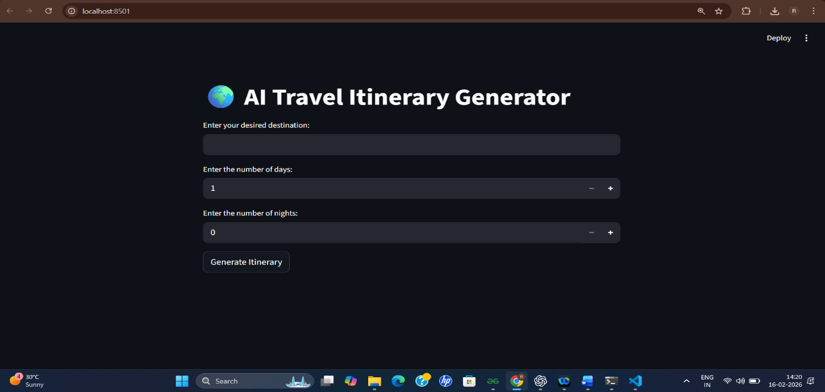
    - AI travel input page

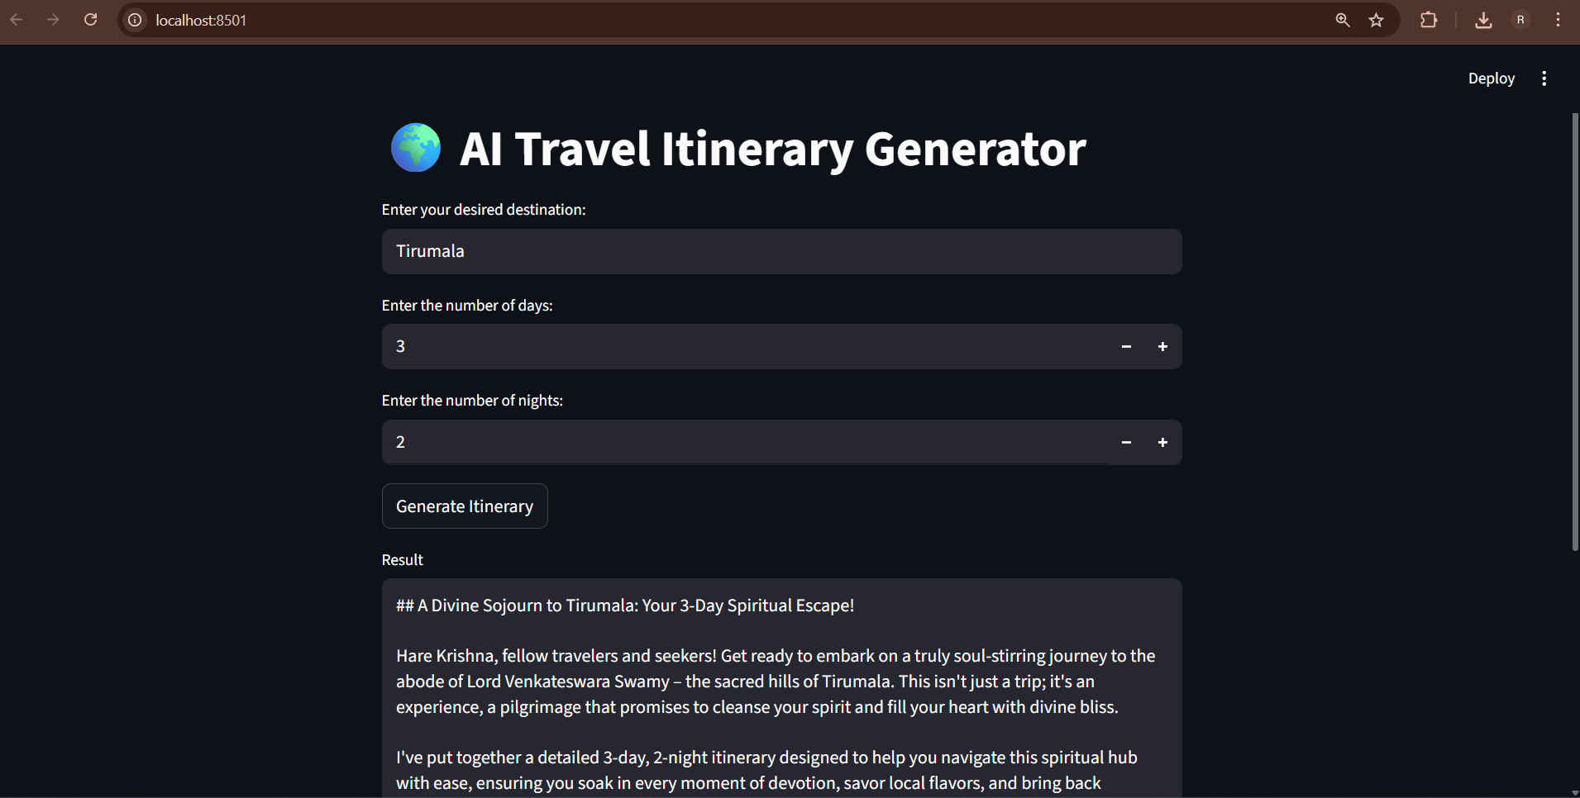

    - AI Generation Output page
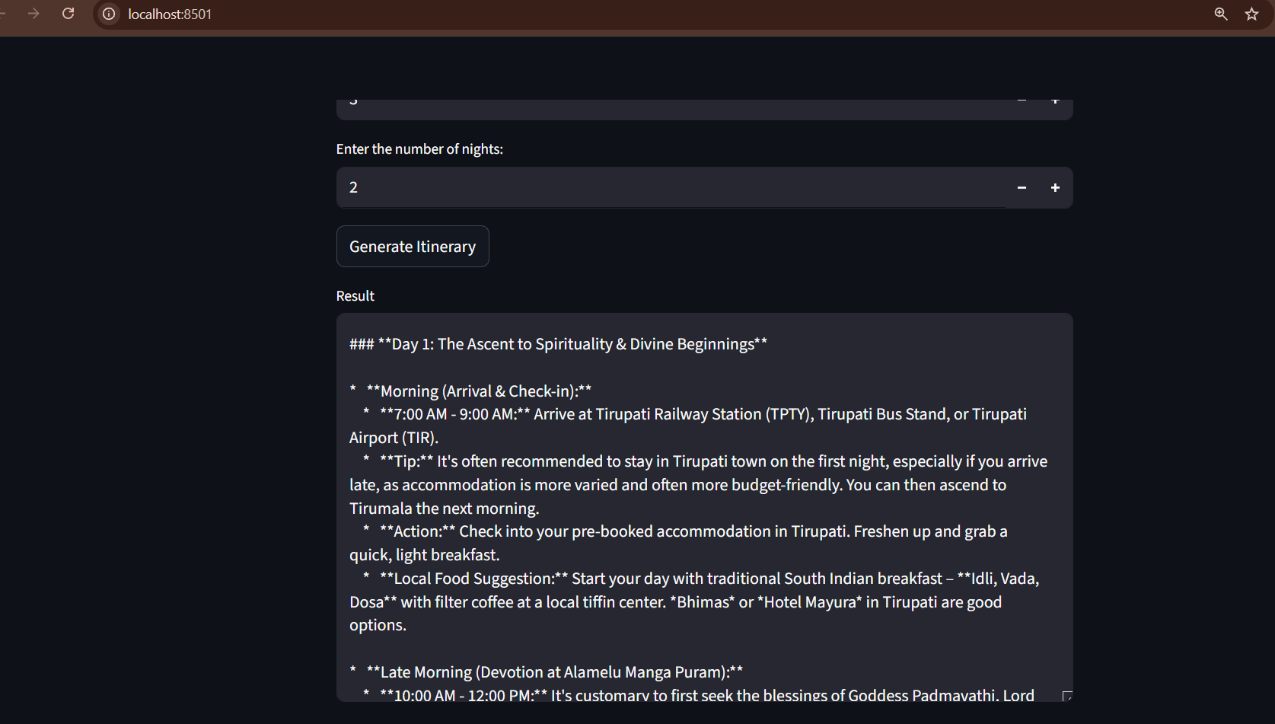

8. ADVANTAGES & DISADVANTAGES
Advantages
- Saves planning time
- Personalized recommendations
- Easy to use
- Demonstrates AI innovation
Disadvantages
- Depends on input quality
- Requires internet connectivity
- AI output may need refinement

9.CONCLUSION
This project demonstrates how Generative AI can simplify travel planning by generating personalized itineraries. It improves user experience and highlights AI’s potential in tourism and recommendation systems.

FUTURE SCOPE
- Add real-time hotel and flight suggestions
- Integrate maps/navigation
- Mobile app development
- User login and saved itineraries
- Cloud deployment

APPENDIX

Source Code:
Available in the project folder

GitHub Repository:

Project Demo:

